**Tutorial 2**

Ex1:

1. i

composite attribute - can be broken into component parts

1. d

associative entity - relationship modeled as an entity type

1. b

unary relationship - relates instances of a single entity type

1. j

weak entity - depends on the existence of another entity type

1. h

attribute - property of an entity

1. l

entity - person, place, object, concept, event

1. e

relationship type - association between entity types

1. c

cardinality constraint - specifies maximum and minimum number of instances

1. g

degree - number of participating entity types in relationship

1. a

identifier - uniquely identifies entity instances

1. f

entity type - collection of similar entities

1. k

ternary - relationship of degree 3

Ex2:

1. Stored attribute: values stored in the database

Derived attribute: values can be calculated from related attribute values (not physically stored in the database)

1. Simple attribute: can be broken down into smaller components

Composite attribute: that has meaningful component parts (attributes)

1. Entity type: a collection of entities that share common properties or characteristics, Relationship type is a meaningful association between (or among) entity types.
2. Strong entity type: exists independently of other entity types

Weak entity type: depends on some other entity type.

1. Degree: the number of entity types that participate in that relationship

Cardinality: constraint on the number of instances of one entity that can (or must) be associated with each instance of another entity.

1. Required attribute: have a value for each entity instance

Optional attribute: may not have a value for every entity instance.

1. Composite attribute: has component parts that give meaning

Multivalued attribute: may take on or more values for an entity instance.

1. Ternary relationship: relationship of degree 3

Three binary relationships: three relationship of degree 2

Ex3:

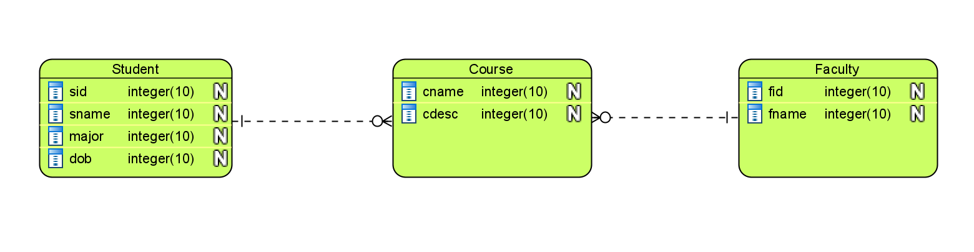

Ex4:

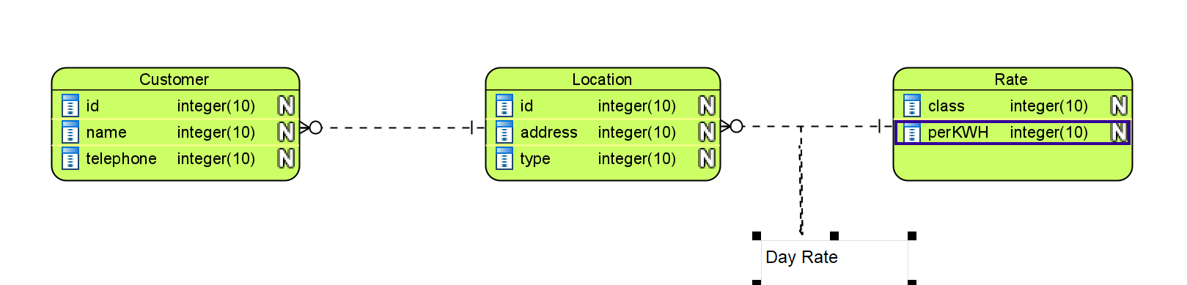

Ex5:

